COMPANY & TASK | Welding and Hot Cutting of Metal
LOCATION OF USE | Factory |  | Assessment  No: |  | 032
PRODUCT NAME | ACETYLENE DISSOLVED
DESCRIPTION OF SUBSTANCE | DISSOLVED GAS
MANUFACTURER | BOC
MANUFACTURERS CONTACT | BOC  Priestley Road,  Worsley  Manchester  M28 2UT  Telephone: 0800 111 333  E-mail: ReachSDS@boc.com
ASSESSOR | Martin Monaghan CMIOSH |  | Date |  | 04 12 25
TITLE | Health and Safety Consultant |  | Review by |  | 04 12 27
Personnel Performing Task  (Please list below)  Trained Operative |  | Time Spent  (Minutes/day)  1hour per week | Training Given 
 |  |  | Yes | 

MSDS Revision Date | Risk- Hazard Statements | Precautionary Statements
08/03/2021 | R12,R5,R6- H280, H220 | P210, P377,P381,P403

Assessment to be conducted in Association with Hazard Data Sheets, a full current copy of which must be attached to this assessment.

Please denote the hazardous properties of the substances used in the task with a 
NEW INTERNATIONAL GLOBALLY HARMANISED HAZARD SYMBOLS

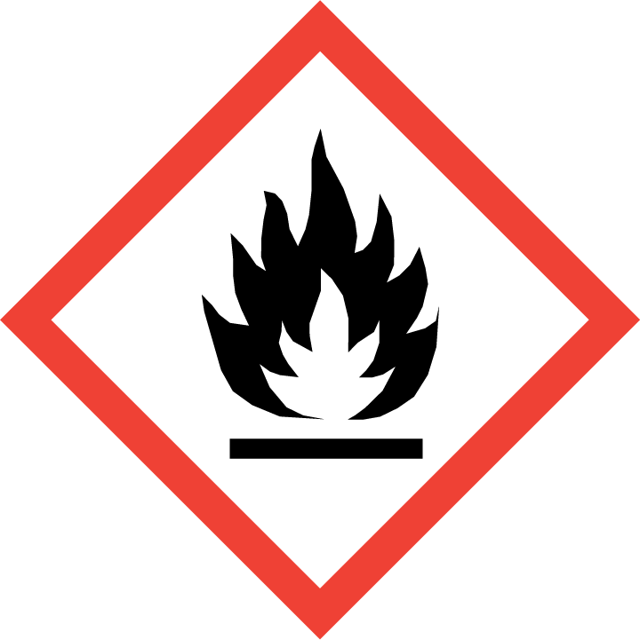 | 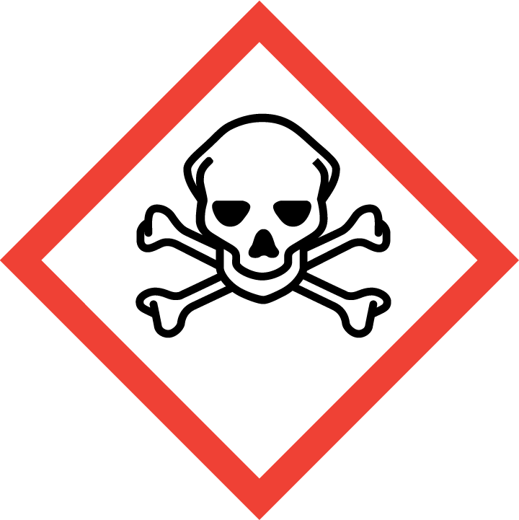 | 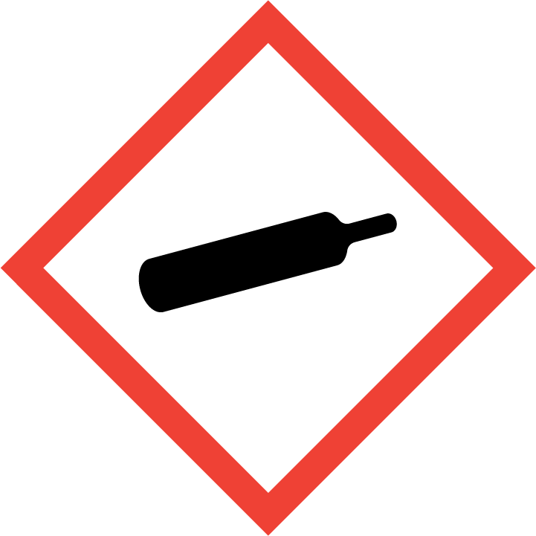 | 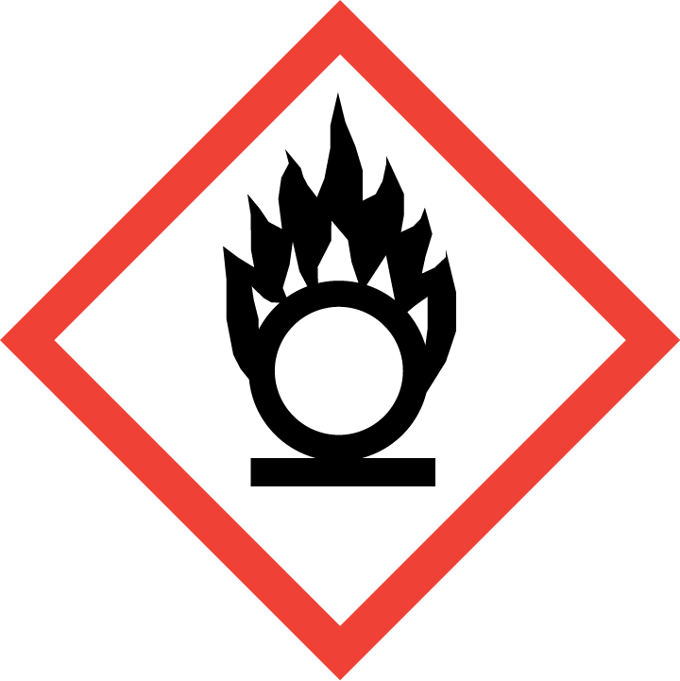 | 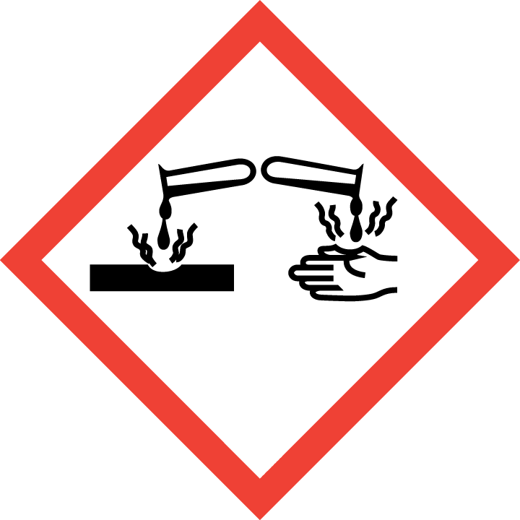 | 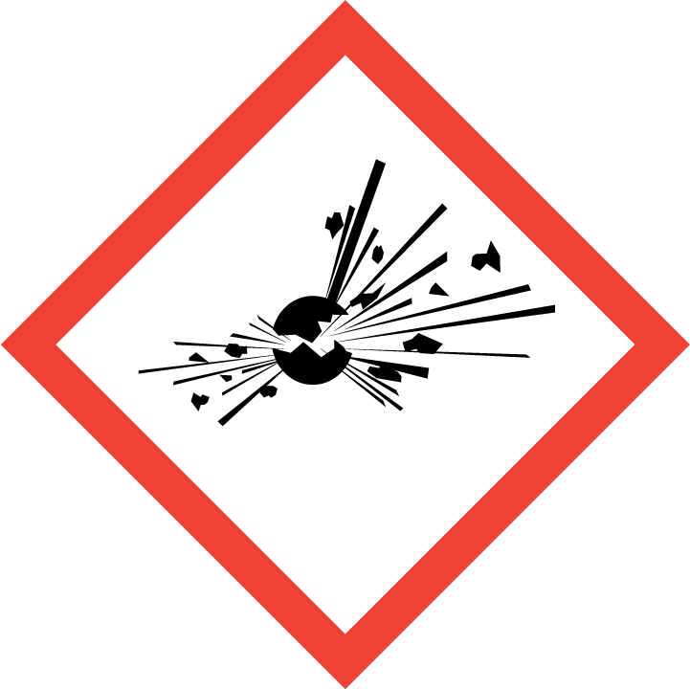 | 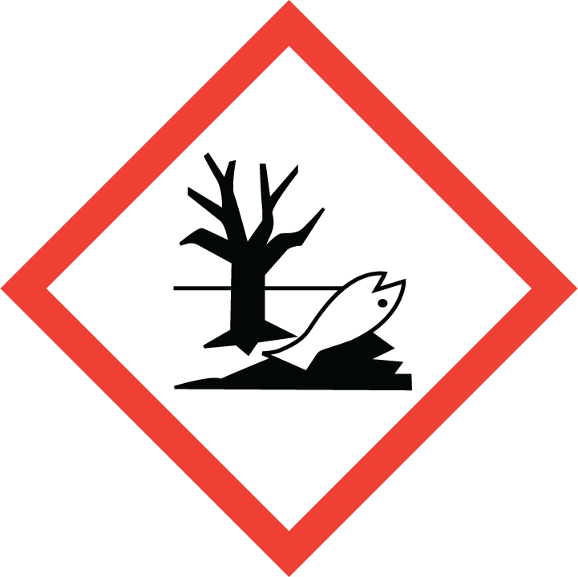 | 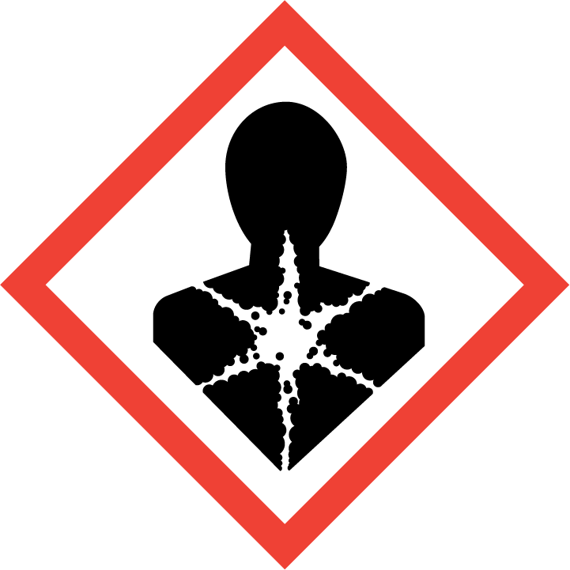
Extremely  Flammable | Toxic | DANGER  Compressed Gas | Oxidising | Corrosive | Explosive | Harmful to the environment | Chronic Health Hazard
 |  |  |  |  |  | 
SMOKING, EATING AND DRINKING ARE PROHIBITED IN THE WORK AREAS.
Information, Instruction and Training must be provided to all users. Young Persons, New or Expectant Mothers and other vulnerable groups must not use or be exposed to this product.
WORKPLACE EXPOSURE LEVELS
IMPORTANT! Asphyxiant in high concentrations!
Victim may not be aware (symptoms loss of mobility/consciousness).
Low concentrations can cause dizziness, headaches, nausea etc
Oxygen detectors should be used when asphyxiating gases may be released.
Refer to manufacturer’s safety data sheet for additional engineering controls and workplace exposure level recommendations.
ROUTE OF EXPOSURE
Skin |  |  |  |  |  | Eyes |  |  |  |  |  |  |  |  | Inhalation |  |  |  | 
Ingestion |  |  |  |  |  | Cuts/abrasions |  |  |  |  |  |  |  |  | Systemic
PERSONS AT RISK
User of product |  |  |  |  |  |  |  | Co workers |  |  |  |  |  | Members of the public |  |  |  | 
ROUTE OF EXPOSURE |  |  |  |  |   FIRST AID MEASURES
Skin/Eye
Inhalation |  |  |  |  | Remove victim to uncontaminated area wearing self contained breathing apparatus. Keep victim warm and rested. Call a doctor. Apply artificial respiration if breathing stopped.
Ingestion
In all cases of doubt, or if symptoms persist seek medical attention. Never give anything by mouth to an unconscious person. If unconscious, place in recovery position and seek medical advice.
PERSONAL PROTECTIVE EQUIPMENT
 |  |  |  |  |  |  |  |  | 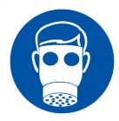 |  |  |  |  |  |  |  | 
To EN166 | Avoid all skin contact |  |  |  |  |  | Safety Footwear |  | Suitable respirator  See below! |  |  |  | Cold insulating gloves |  |  |  | To EN166
 |  |  |  |  |  |  |  |  |  |  |  |  |  |  |  |  | 
Note: Personal RPE not required under normal conditions and where ventilation is adequate and below WEL’s, except in confined spaces. All RPE must be subject to face fit testing and training and storage facilities provided.
HANDLING |  |  |  | STORAGE |  |  |  |  |  | TRANSPORT |  |  |  |  |  | DISPOSAL
Ensure equipment is adequately earthed. Suck back of water in container must be prevented. Purge air from system before introducing gas. Avoid contact with some metals (see MSDS). Do not allow feedback into the container. Use only properly specified equipment which is suitable for this product, its supply pressure and temperature. Refer to suppliers handling instructions. Check valves for damage before use.  Forms explosive acetylides with copper, silver and mercury. Do not use alloys containing more that 65% silver.  Refer to MSDS sheet for full version of safe handling instructions. |  |  |  | Do not remove or deface cylinder labelling. Segregate from oxidant gases and other oxidants stored. Store correctly and in vertical position. Avoid corrosion of cylinder. Check for leaks and damage.  Keep container below 50°C in well ventilated place. Store away from heat and sources of ignition. Keep away from combustible materials. Protect cylinders from falling.  Refer to MSDS for full version of safe storage. |  |  |  |  |  | Observe special transport hazard; Class 2- Section 14 of MSDS and general transport information.  Avoid transport on vehicles where load space is not separated from driver’s compartment! |  |  |  |  |  | Vent to atmosphere in a well ventilated place. Do not discharge where an accumulation could be dangerous. Do not discharge into areas where there is a risk of forming an explosive mixture with air. Use flash back arrestor. Consult supplier for specific recommendations. Return containers to BOC.
GENERAL CONTROL MEASURES
THESE ARE PRECAUTIONS AVAILABLE NOW OR AT SHORT NOTICE, WHICH MUST BE IN PLACE TO PROTECT HEALTH & SAFETY PRIOR TO COMMENCING TASKS!
- Competent trained operatives (users) only to use this product.
- Ensure all non-essential workers removed from work area.
- Ensure safe system of work in place and adhered to.
- Do not breathe the gas.
- Have eyewash and clean water readily accessible.
- Practise good hygiene and ensure adequate welfare and washing facilities available and provide users with barrier and restorative creams.
- Ensure COSHH assessments with accompanying MSDS are made available for all employees and users and for inspection and emergency purpose.
- Carry out manual handling risk assessment for safe handling of cylinders. Use trolley/hand cart designed to transport cylinders.
FIRE PRECAUTIONS
Fire media suitable to use in event of fire: Water. Foam. Dry Powder. Use water spray or fog to control fumes. DO NOT USE CO2,
ACCIDENTAL RELEASE/SPILLAGE PROCEDURES
Where self contained breathing apparatus when entering area, unless atmosphere is proved to be safe. Evacuate area. Ensure adequate ventilation. Eliminate ignition sources. Consider risk of potentially explosive atmospheres. Try to stop release.
MONITORING REQUIREMENTS AND HEALTH SURVEILLANCE
Monitoring examples such as air sampling and health surveillance such as breath or urine tests for conditions such as asthma, dermatitis and respiratory diseases (not exhaustive list), should be undertaken in accordance with the Workplace Exposure Limits information provided on the Manufacturers Safety Data and in particular where these limits are likely to be reached. These limits should not be exceeded.
Guidance: www.hse.gov.uk INDG304 Understanding health surveillance at work

